Mikhail Andreev

EC527 Assignment 2

Using hpcl-18 (2.53 GHz)

**Part 1: Finding OMEGA**

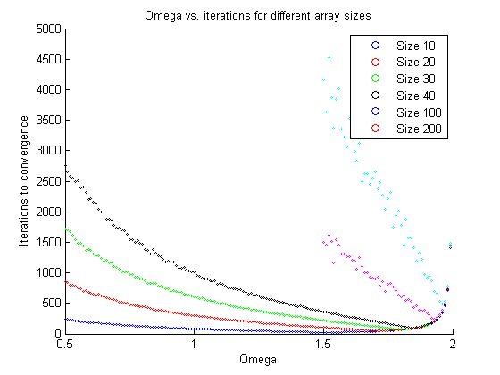

The overall shapes of the graphs are V-like or U-like. When Omega is small, the iterations to convergence are large, and start larger for larger array sizes. As the Omega increases, the iterations needed decrease until they reach a minimum point. After that minimum, then number of iterations increase again. The larger the array size the sharper the change from decreasing iterations to increasing iterations becomes.

From the values graphed we can see the minimum Omega, that is the Omega with the lowest iterations to convergence, is here:

Minimum Omega for Size 10 is 1.500000

Minimum Omega for Size 20 is 1.710000

Minimum Omega for Size 30 is 1.800000

Minimum Omega for Size 40 is 1.840000

Minimum Omega for Size 100 is 1.930000

Minimum Omega for Size 200 is 1.960000

From these values, we can see that as the array size rises, so does the optimal Omega value for that array size.

Different Omega selections have different levels of sensitivity on the iterations to convergence. When the array size is small, different Omega choices have little change on the iterations to convergence. When the array size becomes larger however, the effects become much more pronounced. Sensitivity also greatly increases after the optimal value, so for larger array sizes, increasing the omega past the optimal value causes a very large spike in the iterations to college.

Assuming the Omega value is optimal, the size of the array will affect the iterations to convergence. Even when comparing iterations to convergence for different array sizes at optimal Omega, larger array sizes will require more iterations.

**Part 2: Serial SOR Optimizations**

**Part 3: Cost of Multithreading**

**Part 4: Multithreaded SOR**